Computer vision

Homework 02

姓名 ： 蘇宛琳

系所 ： 電信所碩一

學號 ： R05942060

指導教授 ： 傅楸善老師

Computer Vision Report – Homework 02

R05942060 蘇宛琳

* Write a program to generate Image Matching (Detecting Motion Vectors)
  + Camera calibration i.e. compute #pixels/mm object displacement
  + Use lens of focal length: 16mm, 25mm, 55mm
  + Object displacement of: 1mm, 5mm, 10mm, 20mm
  + Object distance of: 0.5m, 1m, 2m
  + Camera parameters: 23.7mm * 15.6mm ==> 4672*3104 pixels
  + Are pixels square or rectangular?
  + Calculate theoretical values and compare with measured values.
  + Calculate field of view in degrees of angle.
* 設計原理
* 影像位移理論值計算

1. 透過下圖的原理，可以經由相似三角形得到以下的公式:

影像位移= (焦距*實際位移) / 物距

影像位移

焦距

物距

實際位移

舉例說明: 焦距=18mm，實際位移=1mm，物距=600mm

>> 影像位移=(18*1)/600=0.03mm

1. 在換算影像位移(mm)和影像位移(pixel)時，我們必須先得知相機的感感應器大小和影像大小，可得比例尺。

比例尺 = 4672pixel / 23.7mm

4672pixel

23.7mm



15.6mm

3604pixel

Pentax K-7

Sensor parameters

舉例說明: 影像位移為0.03 mm >> (4672/23.7)*0.03 = 6 pixel

* 視野夾角計算
* 感應器大小 = *w，*焦距 = *f，*視野夾角的計算，如下式



焦距

Sensor parameter

舉例說明 :

*d* = 23.7 mm，*f* = 18 mm，度

* 影像位移計算值計算

Step1. 先利用MATLAB中的Data Curaor取出魯夫的center大約位置

還有依據影像中魯夫的大小，來取設定block大小。

舉例說明: 焦距(18mm) 物距(600) 的影像

假設中心center=(2265,1655)，block=551x371

|  |  |  |  |  |  |  |  |  |  |  |  |
| --- | --- | --- | --- | --- | --- | --- | --- | --- | --- | --- | --- |
|  |  |  |  |  |  |  |  |  |  |  |  |
|  |  |  |  |  |  |  |  |  |  |  |  |
|  |  |  |  |  |  |  |  |  |  |  |  |
|  |  |  |  |  |  |  |  |  |  |  |  |
|  |  |  |  |  |  |  |  |  |  |  |  |

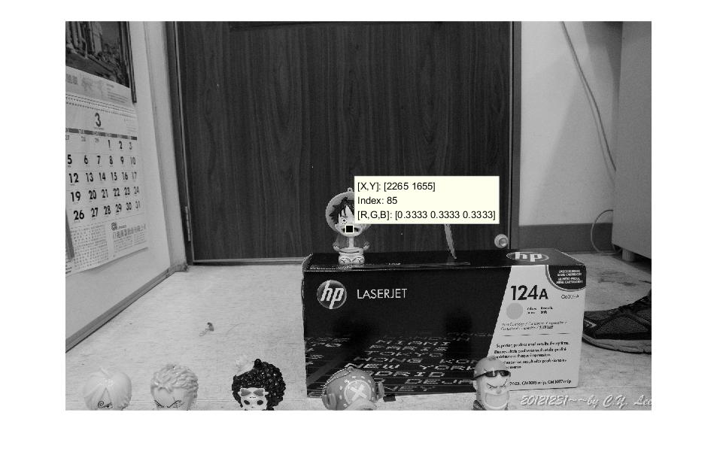

367

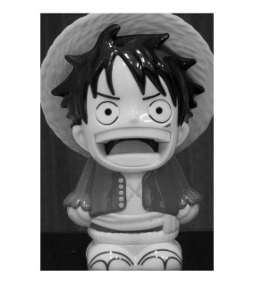

551

(1655,2265)

Step2. 接著透過第一堂課所教的correlation方式，來比較兩張圖魯夫

位置的水平位移的pixel數，且因為透過Data Curaor所取出的

中心位置並不準確，故將其周圍約10個pixel左右皆設為中心

點，分別與圖b進行correlation，找出correlation的最小值，即

可求得最準確之a圖中心點，並同時設定search range > 位移理

論值*2，此時計算與圖b最佳的中心點的位移，如此一來不用

跑整張影像的向量圖，就可以輕鬆針對魯夫的移動來求得計算

值。

舉例說明:

圖a 為焦距(18mm) 物距(600) 位移(0)

圖b為焦距(18mm) 物距(600) 位移(20)

取周圍10個點為中心點，故圖a的center=(1650~1659,2260~2269)

Step1.

Center(1)=(1650,2260) Block=551x371

Search range=490 >位移理論值*2=120*2=240

Search range

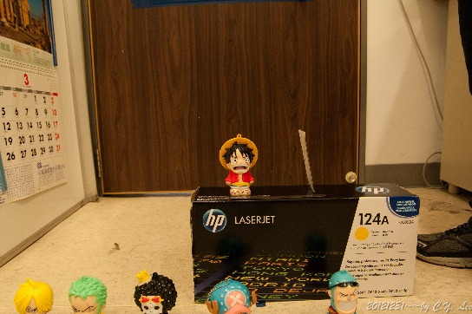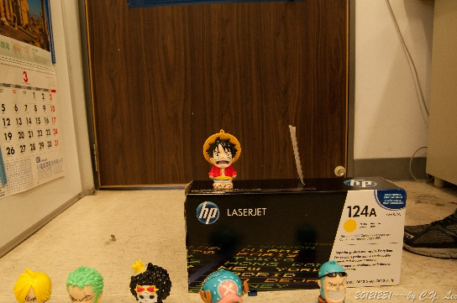

|  |  |  |  |  |  |  |  |  |  |  |  |  |
| --- | --- | --- | --- | --- | --- | --- | --- | --- | --- | --- | --- | --- |
|  |  |  |  |  |  |  |  |  |  |  |  |  |
|  |  |  |  |  |  |  |  |  |  |  |  |  |
|  |  |  |  |  |  |  |  |  |  |  |  |  |
|  |  |  |  |  |  |  |  |  |  |  |  |  |
|  |  |  |  |  |  |  | 圖a |  |  |  |  |  |

displacement

圖b

計算correlation --> dmin(1)-->dx(1) , dy(1)

接著依此類推計算到center(10)，計算correlation --> dmin(10)

-->dx(10),dy(10)

Step2.

取得最小的dmin(k)，則center(k)最為準確，且所得到的dx(k) ,

dy(k)，即為影像位移計算值。

* 程式碼

%%%% use correlation to do image matching a

a=imread('600mm_0mm.jpg');a=rgb2gray(a);a=double(a);

b=imread('600mm_5mm.jpg');b=rgb2gray(b);b=double(b);

%%%% assume the block and search size and center

% block size

Bx=551; hBx=fix(Bx/2);

By=371; hBy=fix(By/2);

% search size ( hS=10 is equal that search size is 20)

hS=10;

% padarray zeros in image a and b

x=1650:1654;

y=2272:2276;

for i=1:length(x)

d=[];

for r=x(i)-hS:x(i)+hS

for c=y(i)-hS:y(i)+hS

d(r-x(i)+hS+1,c-y(i)+hS+1)=norm(a(x(i)-hBx:x(i)+hBx,y(i)-hBy:y(i)+hBy)-b(r-hBx:r+hBx,c-hBy:c+hBy));

end

end

[~,row1{i}]=min(d);

[dmin(i),col(i)]=min(min(d));

row(i)=row1{i}(col(i));

end

[~,k]=min(dmin);

xc=x(k);

yc=y(k);

dx=row(k)-hS-1;

dy=col(k)-hS-1;

* 實驗結果

|  |  |  |  |  |  |  |  |
| --- | --- | --- | --- | --- | --- | --- | --- |
| 焦距(mm) | 物距(mm) | 實際  位移(mm) | 影像  位移  理論值(mm) | 影像  位移  理論值  (pixel) | 影像  位移  計算值  (pixel) | 視野  夾角  (度) | 採用  Center  Block |
| 18 | 600 | 1 | 0.030 | 6 | 7 | 56.64 | Center  (1650,2272)  Block  551x371 |
| 5 | 0.150 | 30 | 26 |
| 10 | 0.300 | 60 | 54 |
| 20 | 0.600 | 120 | 101 |
| 1200 | 1 | 0.015 | 3 | 2 | Center  (1612,2339)  Block  291x201 |
| 5 | 0.075 | 15 | 16 |
| 10 | 0.150 | 30 | 30 |
| 20 | 0.300 | 60 | 55 |
| 1800 | 1 | 0.010 | 2 | 3 | center  (1590,2324)  Block  191x141 |
| 5 | 0.050 | 10 | 9 |
| 10 | 0.100 | 20 | 19 |
| 20 | 0.200 | 40 | 45 |
| 53 | 600 | 1 | 0.088 | 17 | 21 | 77.40 | center  (1670,2277)  Block  1401x1001 |
| 5 | 0.441 | 87 | 61 |
| 10 | 0.883 | 174 | 128 |
| 20 | 1.766 | 384 | 252 |
| 1200 | 1 | 0.044 | 9 | 10 | center  (1630,2400)  Block  771x501 |
| 5 | 0.220 | 44 | 45 |
| 10 | 0.441 | 87 | 78 |
| 20 | 0.883 | 174 | 162 |
| 1800 | 1 | 0.029 | 6 | 12 | center  (1322,2400)  Block  521x342 |
| 5 | 0.147 | 29 | 37 |
| 10 | 0.294 | 58 | 58 |
| 20 | 0.588 | 116 | 101 |
| 135 | 600 | 1 | 0.225 | 44 | 50 | 85.98 | center  (1597,2221)  Block  2531x1801 |
| 5 | 1.125 | 222 | 159 |
| 10 | 2.250 | 444 | 430 |
| 20 | 4.500 | 887 | 788 |
| 1200 | 1 | 0.113 | 22 | 23 | center  (1550,2500)  Block  1650x1101 |
| 5 | 0.563 | 111 | 109 |
| 10 | 1.125 | 222 | 200 |
| 20 | 2.250 | 444 | 414 |
| 1800 | 1 | 0.075 | 15 | 16 | center  (1140,2325)  Block  1201x801 |
| 5 | 0.375 | 74 | 78 |
| 10 | 0.750 | 148 | 149 |
| 20 | 1.500 | 296 | 310 |